Brighton & Sussex Medico-Chirurgical Society lecture
Thursday 2 March 2020
7-8pm Audrey Emerton Building, Ground Floor Lecture Theatre
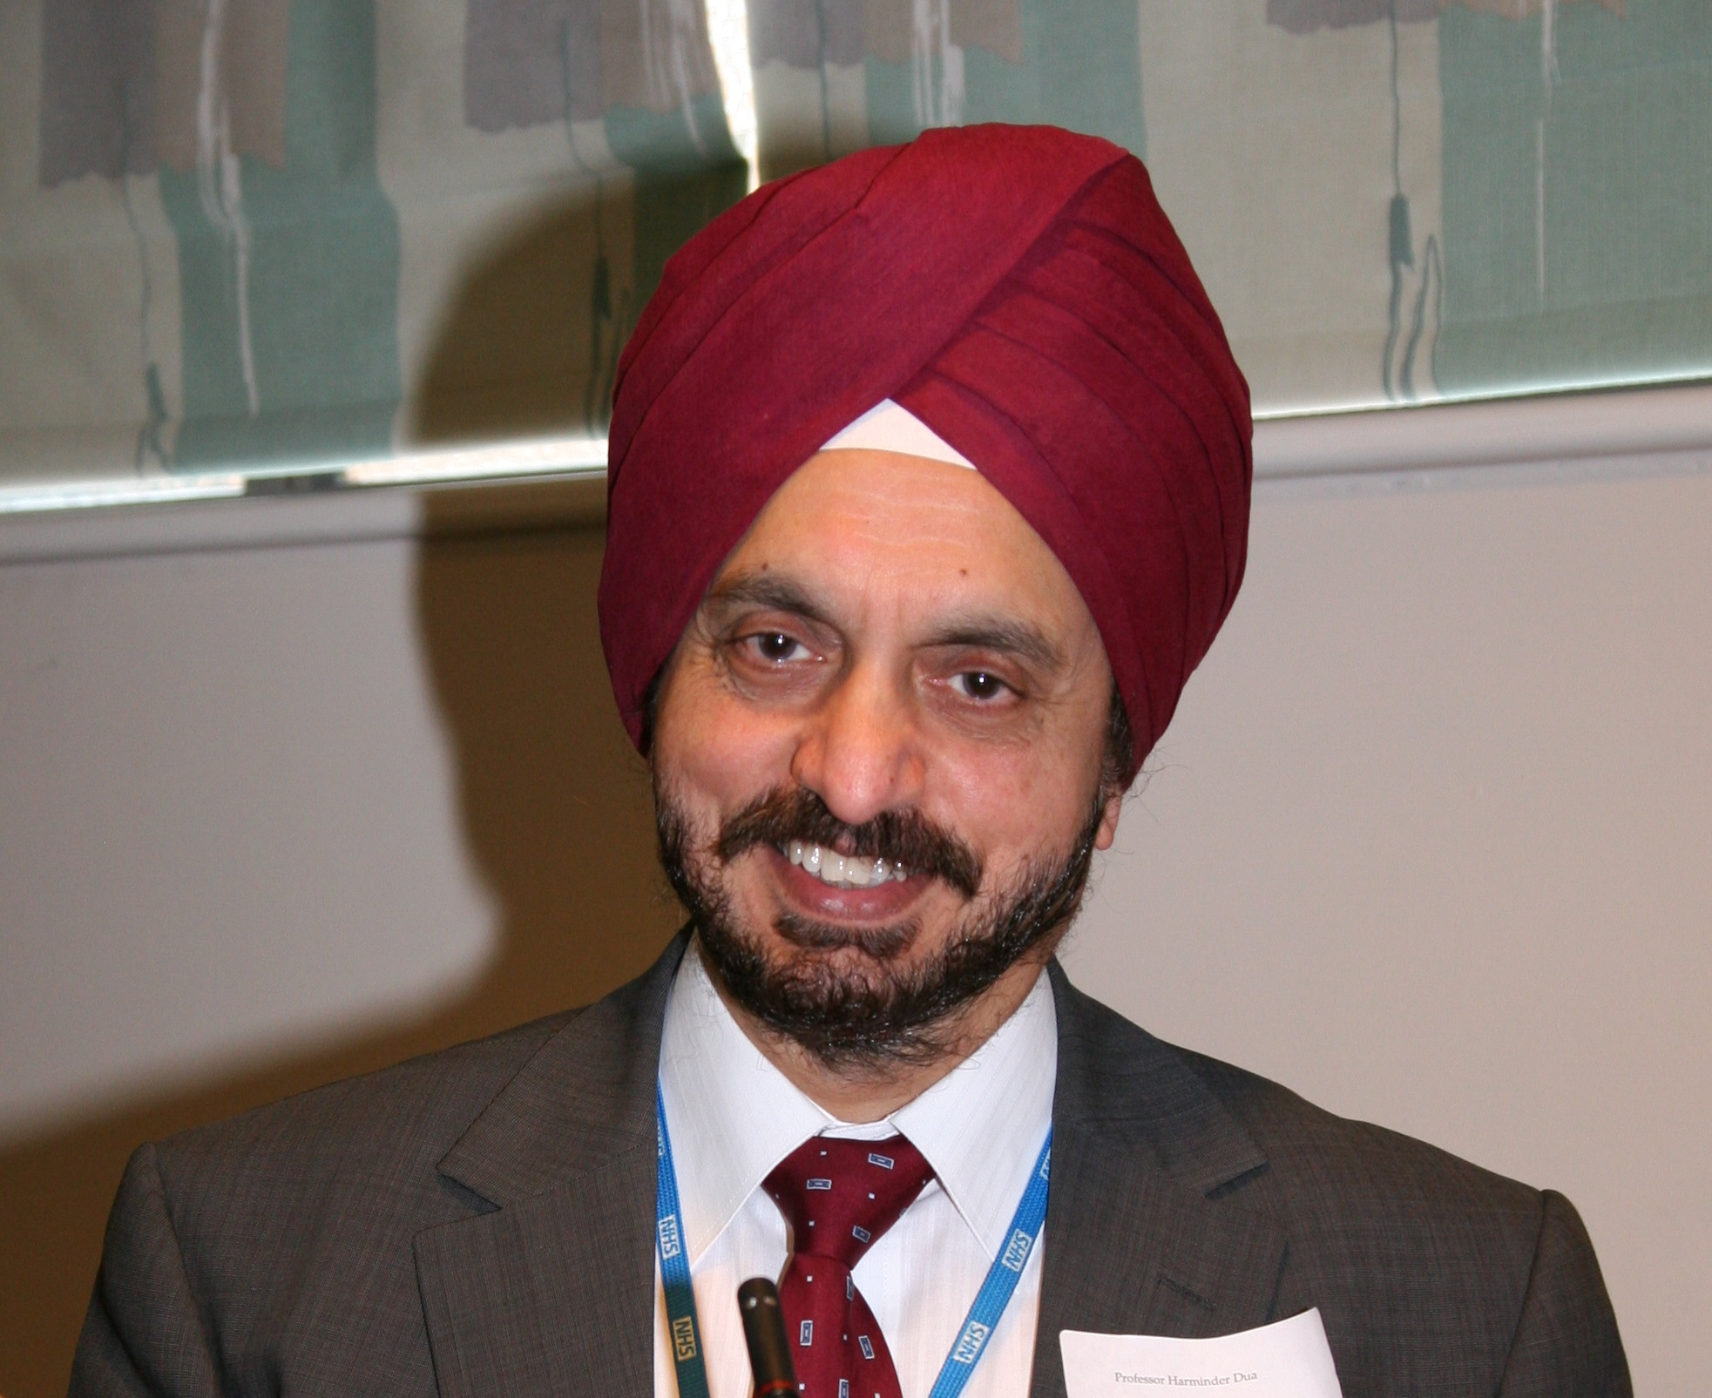
MBBS, DO, DO(London), MS, MNAMS, FFMLM, FRCS(Edinburgh), FEBO, FRCOphth, FRCP(Edinburgh, Hon.), FCOptom.(Hon.), FRCOphth.(Hon.), MD, PhD, is Chair and Professor of Ophthalmology at the Queens Medical Centre, University of Nottingham since 1994 and joint Head of Service, Department of Ophthalmology, Queens Medical Centre, Nottingham since January 2018. He is also Honorary Professor of Universita della Svizze, Lugano and Faculty member, European School for Advanced Studies in Ophthalmology since 2010.
Harminder S Dua was made Commander of the most excellent order of the British Empire by Her Majesty Queen Elizabeth II in her 2019 Birthday Honours list.

Professor Harminder Dua, CBE
Steering the ship: From student ship to leadership
He is currently Editor-in-chief of the Journal of EuCornea, President of The European association for vision and eye research Foundation (EVERf, re-appointed 2017), member of the Academia Ophthalmologica Internationalis and the American Ophthalmological Society, Board member of the International Council of Ophthalmology and Trustee of the Sussex Eye Foundation and immediate past Master of the Oxford Ophthalmological Congress, UK. He was the 9th President of the Royal College of Ophthalmologists UK (2011-14) and has served as Editor-in-Chief of the British Journal of Ophthalmology (2007-14); President of the European society of cornea and ocular surface disease specialists (EuCornea, 2011-13), President of the European association for vision and eye research (EVER, 2008) and of the EVER Foundation (EVERf, 2010-14). He was Trustee of Sight Savers International (2008-12) and was member of the International steering committee of the second Dry Eye Workshop and served on the ‘Definition and Classification committee’ (DEWS II, 2015-17).
Amongst his over one hundred and twenty five awards and accolades are The Rotary Foundation Global Alumni Service to Humanity Award (2013), The Times Higher Education Award 2014 for ‘Research project of the year’; Vice-chancellor’s medal (2016), ESASO Award for Excellence in Teaching and Training (2019), the Melvin Jones Fellow (Award) Lions Clubs International Foundation, for dedicated humanitarian services (2019), and several medals and eponymous lectures. He has recently been elected as an Honorary Fellow of the Royal College of Ophthalmologists UK, and is Honorary Fellow of the Royal College of Physicians of Edinburgh and the College of Optometrists UK, the highest accolade conferred by the respective Colleges. He was listed by the magazine ‘Ophthalmologist’ in the top 20 most influential individuals in Ophthalmology worldwide (2014); and amongst in the top 100 in 2016 and 2018. He was one of five Ophthalmologists in the list of ‘Britain’s Top Doctors’ (2010) published by The Times magazine. He has been endowed with honorary life memberships of four international academic societies. One eponymous lecture, “The Dua Lecture” Birmingham, and a seminar room in the Nottingham post-graduate centre, “The Dua Room” have been named in his honour.
He has successfully supervised 48 PhD and MD post-graduate students, has published over 375 papers and has an H-index of 67 with over 17000 citations. His discovery of the pre-Descemets layer (Dua’s layer) in 2013 has enhanced understanding of lamellar corneal surgery, posterior corneal pathology and led to the innovation of three novel surgical procedures. The layer has been recently endorsed by the board of the American Association of Ophthalmic Oncologists and Pathologists (AAOOP). Prof. Dua is High Sheriff of Nottinghamshire in nomination, to assume office in 2021.

