Brighton & Sussex Medico-Chirurgical Society lecture

Thursday 1 October 2020 7-8pm Audrey Emerton Building, Ground Floor Lecture Theatre

Ms Lisa Leonard, Ms Lisa Tourret, Ms Laura Hamilton, Ms Riem Johnson

Tales from four Hand Surgeons

Lisa Leonard BA MSc FRCS(T&O)Consultant Orthopaedic Hand Surgeon Chief of Surgery Division

EDUCATION: Clare College, Cambridge University - 1987 – 1990, Birmingham Medical School - 1990 – 1993, Cardiff University (distance learning) - 1999 - 2001
QUALIFICATIONS: FRCS (Trauma and Orthopaedics) - May 2004, MSc in Orthopaedic Engineering - July 2002, MB ChB – 1993, BA Medical Sciences (Upper Second) – 1990
FELLOWSHIP & AWARDS: AO Trauma Fellowship – Seattle – July/Aug 2005 Oxford Hand Fellow – July 2004 – June 2005 Research Fellowship – Royal College of Surgeons – 2000 Arthritis Research Campaign – Project Grant award 2001

Current Posts: Chief of Surgery Division BSUH, appointed 1st December 2017Consultant Orthopaedic & Hand Surgeon, Brighton and Sussex University Hospitals. Appointed 17th July 2006 Special interests: trauma, hand, wrist and elbow.

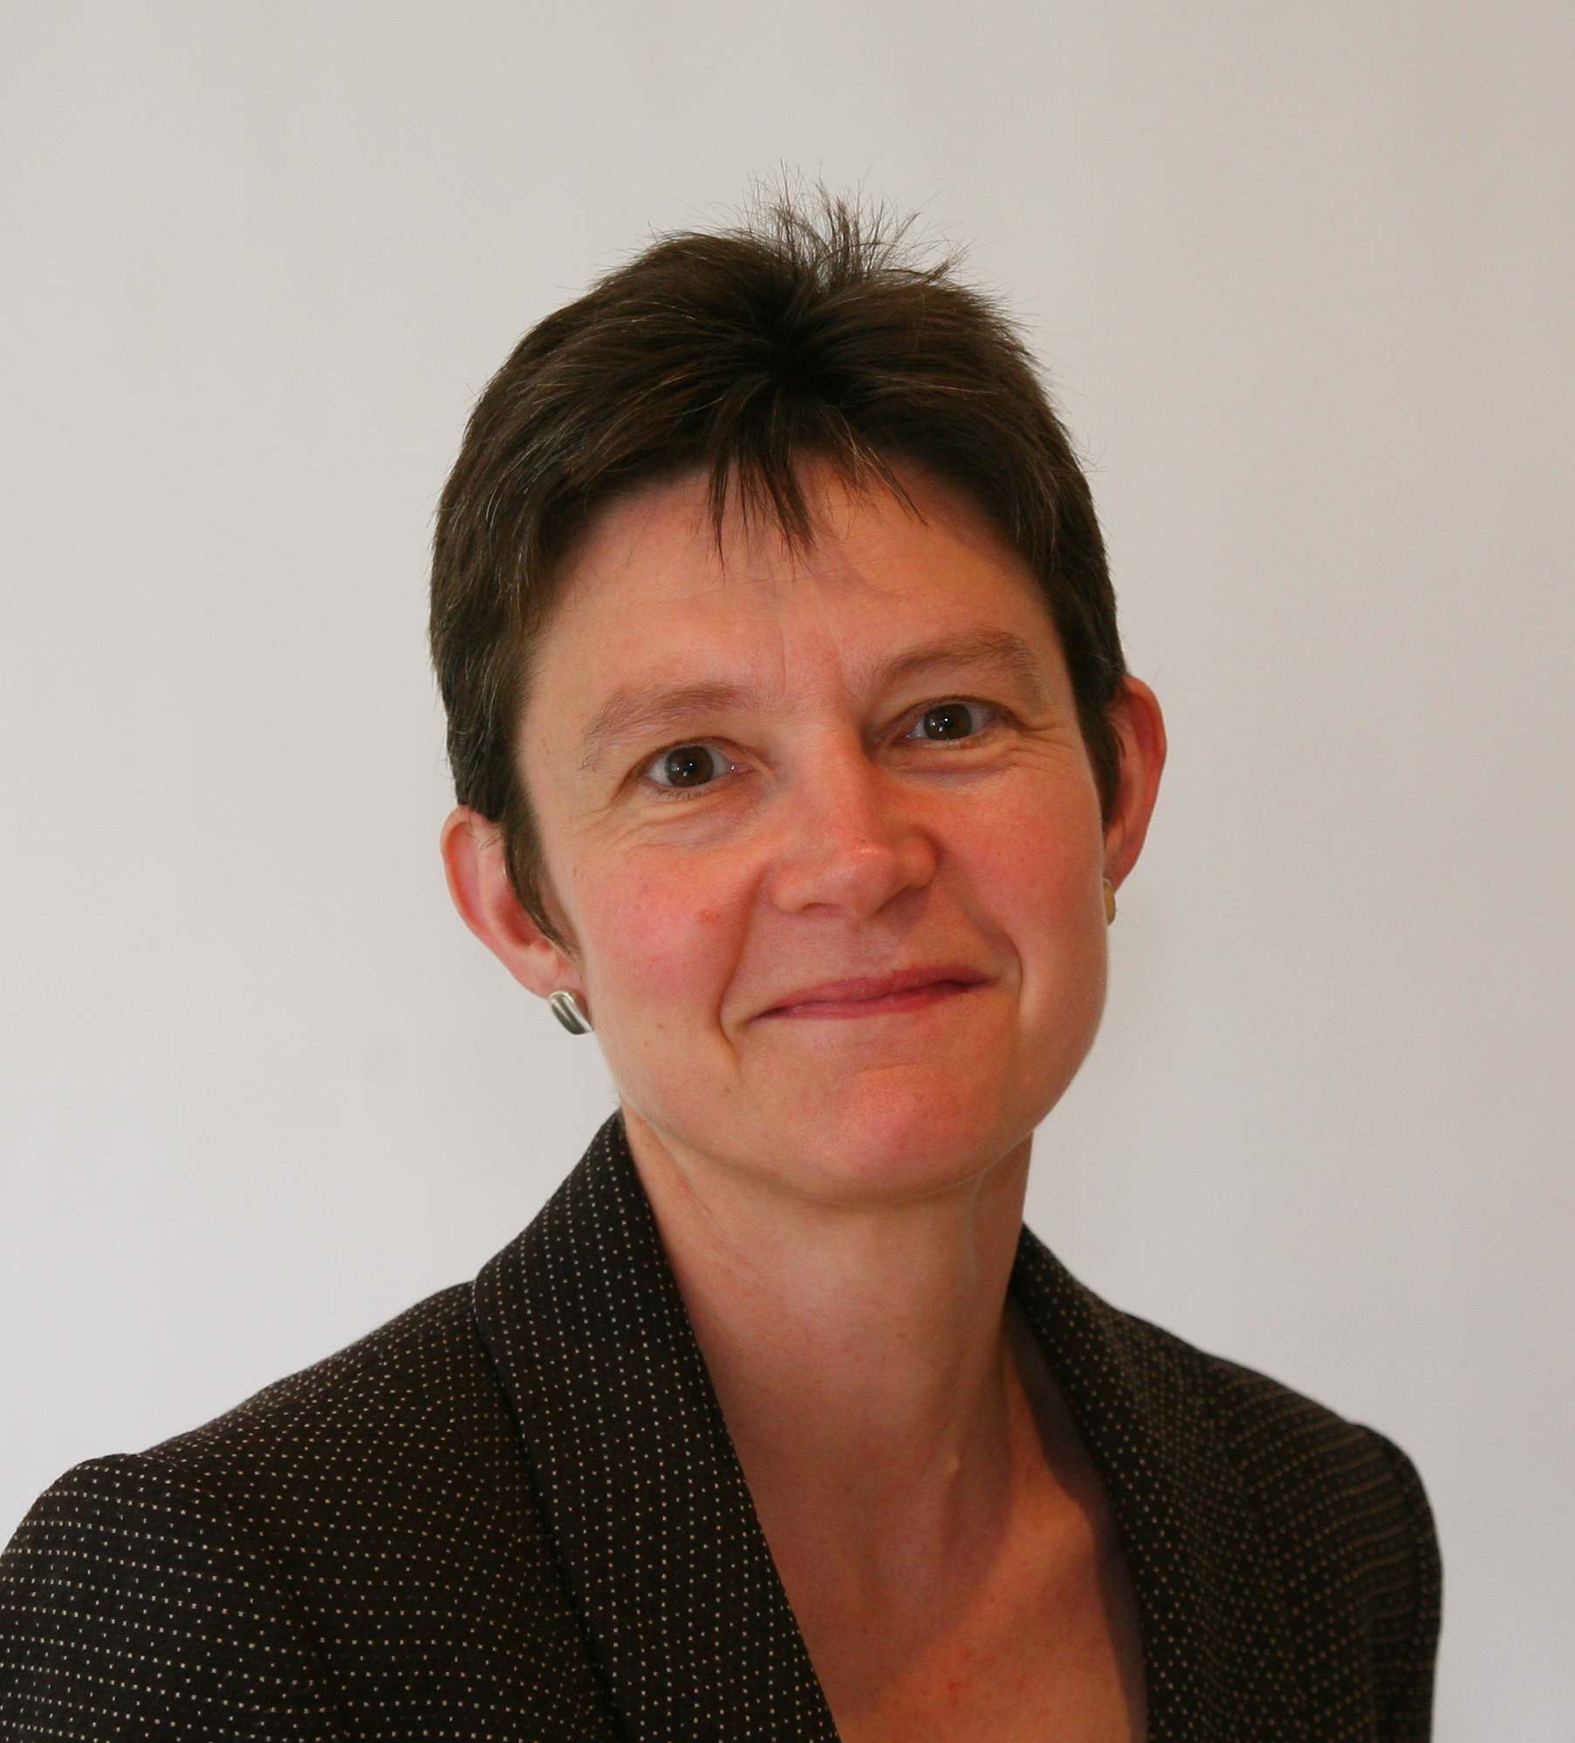

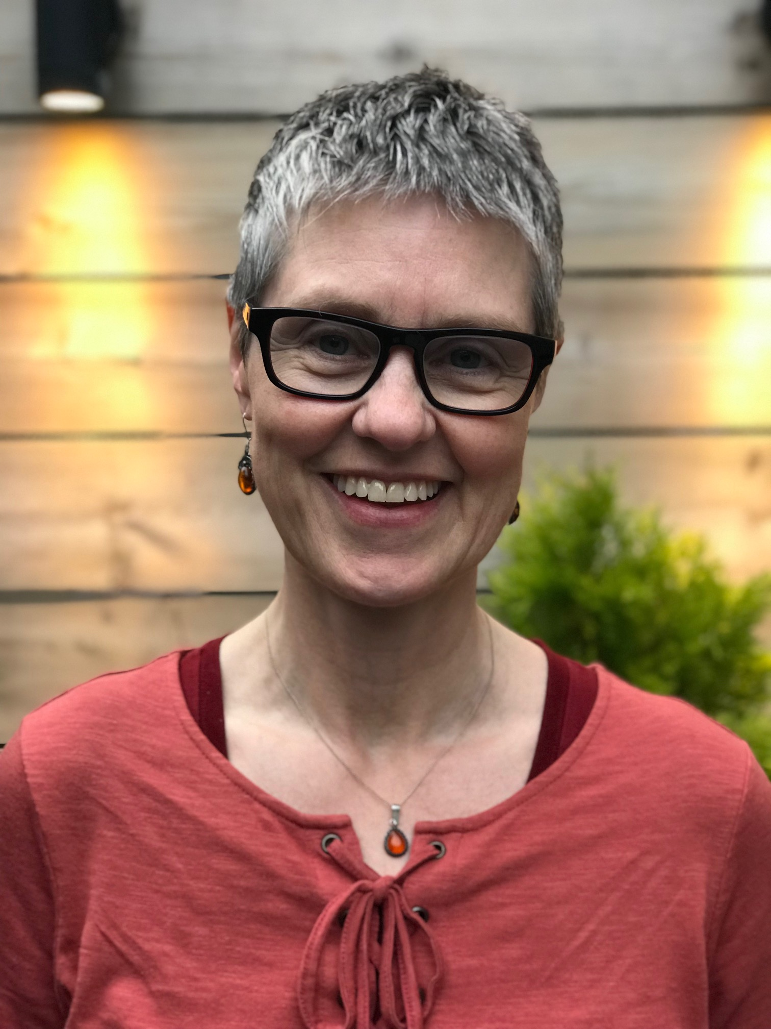

Ms Lisa Tourret MB ChB, MSc, FRCS (Lon), FRCS (Tr and Orth). Consultant Orthopaedic Surgeon
I have been a Consultant hand surgeon for 14 years. I completed my higher training in Newcastle upon Tyne and spent a year and half in New Zealand specialising in Hands at the National Hand Unit in Auckland.
The first 6 years of my Consultant career was in the North East and I moved to Brighton in 2012 where I helped to set up the Regional Hand service we have today.

Miss Laura Hamilton MBBS, MA, MRCS, MSc, FRCS
Laura Hamilton was educated at Oxford University before finishing her medical degree at St. Georges Hospital Medical School in London. She trained all over the South East before becoming a Registrar on the London Training Rotation. Laura achieved a distinction in her T&O MSc dissertation on Complex PIPJ fracture dislocations and now supervises T&O trainees completing their Masters. Laura completed her training in hand surgery as a Hand Fellow at King’s College Hospital, London. This was supplemented with secondment to Wrightington and an RCSE Travelling Fellowship to spend time with PC Ho performing complex arthroscopies in Hong Kong. She was appointed substantive Orthopaedic Consultant in hand and wrist surgery in Brighton in 2017. Laura lives with her husband and 2 little boys in her new house on the South Downs. She loves to draw and teach, and is passionate about supporting trainees and encouraging minorities into surgery.

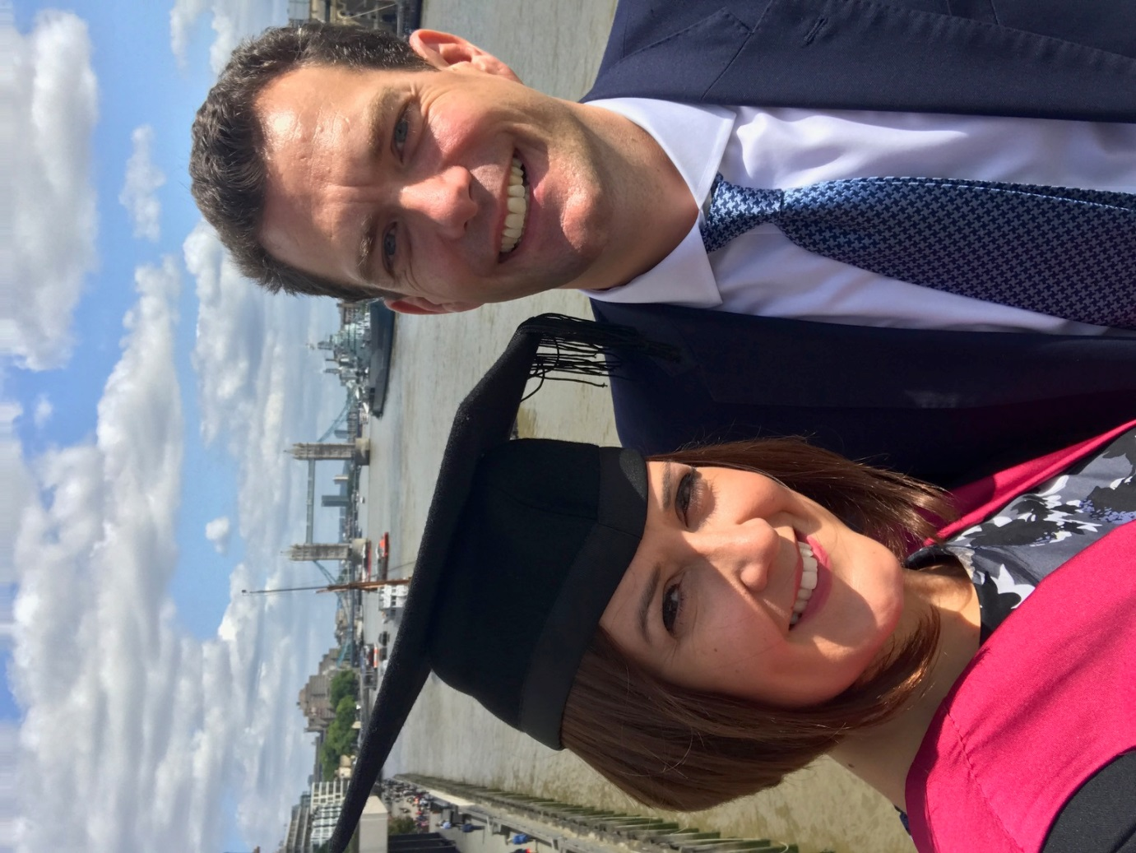

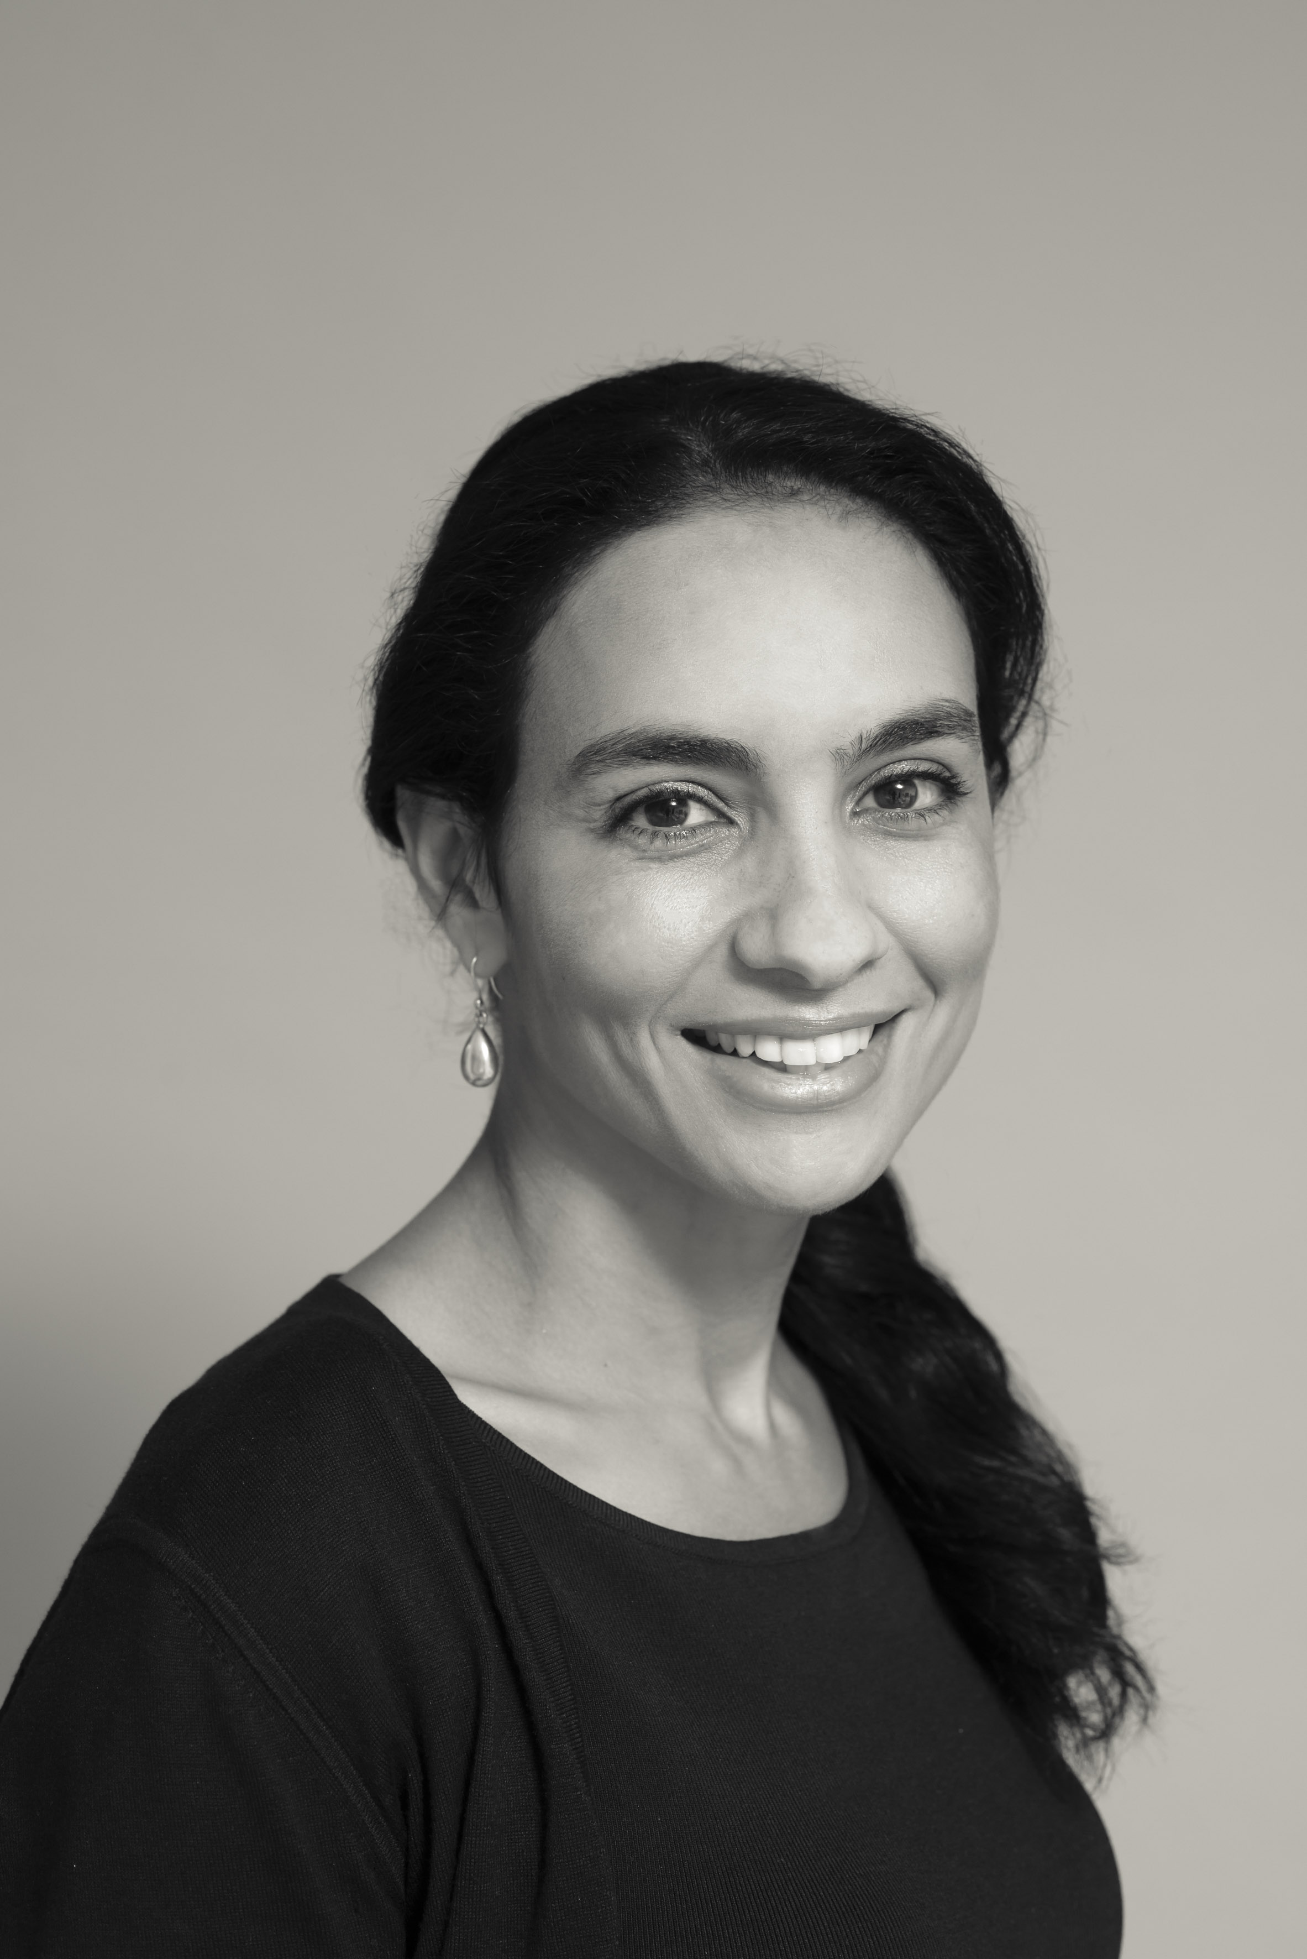
Riem Johnson MB ChB, MD, FRCS(Tr&Orth), BrDiploma Hand Surgery
Riem Johnson was educated at Leicester University and undertook her surgical training in the NorthEast of England. She underwent a period of research in General Surgery and was awarded a Doctorate (MD) at the University of Newcastle prior to undertaking her higher surgical training in Trauma & Orthopaedics. She completed her training with a post-CCT Hand Fellowship at Chelsea & Westminster Hospital (October 2016-October 2017). Riem went on to become a locum hand consultant at the Pulvertaft Hand Unit in Derby (October 2017-January 2018) during which time she was awarded the British Diploma of Hand Surgery (March 2018) by the BSSH and University of Manchester. She was appointed as a substantive orthopaedic hand surgeon at the Brighton & Sussex University Hospitals Trust and moved down with her family to start work here in April 2018. She takes an active role in training and quality and safety, taking on the clinical governance lead for T&O since March 2019. Riem continues her research interest with recent collaboration with Imperial College and is currently the Principal Investigator for an NIHR funded randomised control trial regarding Dupuytren’s disease.

NO NEED TO BOOK – JUST SIGN IN ON ARRIVAL – NO CHARGE

ALL WELCOME

